Overview
Embark on an unforgettable journey in Mongolia that combines culture, wilderness, and adventure. The trip begins on the grandest note possible: attendance at the Naadam Festival in Ulaanbaatar. This is the country’s annual national celebration which dates back to the days of Ghengis Khan and includes an action-packed agenda of events, sportsmanship, and rituals.
After this high energy start, we trade the buzz of the city for the serenity of the Mongolian steppe as we spend 5 days cycling across vast plains before entering Khan Khenty, a spectacular land of wooded mountains. Here we spend 2 days trekking before capping things off with a ride on horseback, traversing wooded hills, grassy river valleys and rugged mountains in true Mongol fashion.
All along the way we will sleep under the stars in tents, encounter nomads tending to their flock, and relish in views of one of the world’s wildest natural frontiers.
This is classic Mongolia done right and SPICE ROADS (www.spiceroads.com) has coordinated this very specialized tour for us.
Black solid line: transfer by A/C van
Red dotted line: bike, hike & ride
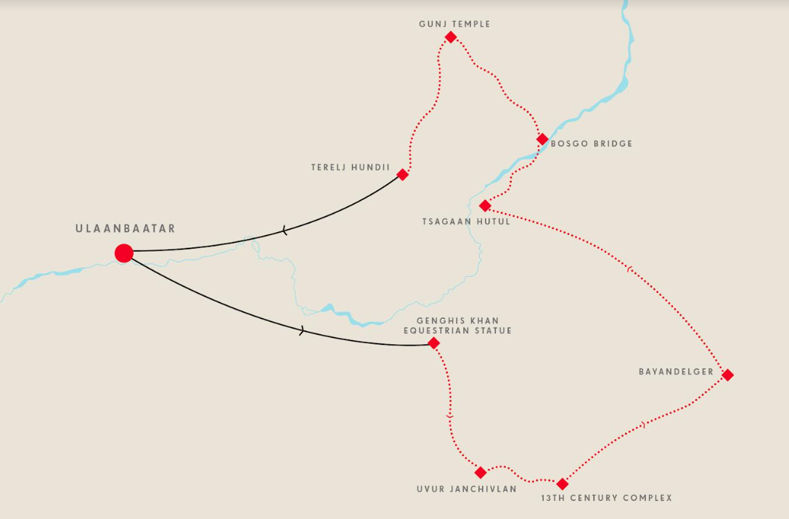

Arrivals and the Nadaam Festival

All airport transfers included
Welcome to Mongolia! Upon arrival in the capital city of Ulaanbaatar make your way to the centrally located and iconic Bayangol hotel.
After getting settled, your private guide will lead you on an orientation tour around the city, taking you to the grand statues of Genghis Khan and Sukhbaatar in the central square before visiting the National Museum of Mongolia. Here you’ll be able to familiarize yourself with the trajectory of cultural and political development in this fascinating country, from prehistory to the modern era.
Time permitting, we can also pay a visit to another museum and you can choose from the Choijin Lama Museum or the Fine Arts Zanabazar Museum. The former displays Buddhist architecture, artworks and religious masks while the latter contains priceless works by Mongolian masters spanning several centuries.
This afternoon, in Ulaanbaatar’s central square, you will also be able to witness Deeltei Mongol, a national costume festival which takes place the day before the Naadam Festival. Vibrant and colorful doesn’t even begin to describe this event!
In the evening you are invited for a special Mongolian welcome dinner, preceded by a show of traditional music, throat singing and contortion.
The Naadam Festival is Mongolia’s biggest national celebration, held yearly between the 11th and 12th of July. If you could distill everything which is unique about Mongolian culture into one event, this is it! And, well, that’s what it is meant to be: a celebration of the unique Mongolian way of life, steeped in rich tradition and history. In the days of Genghis Khan, Naadam was a way to celebrate victory though, over the centuries, it has evolved into the annual multi-day extravaganza we know today. Ulaanbaatar’s National Sports Stadium is where the action takes place and here we will witness the grand opening ceremony, which consists of an elaborate introduction ritual featuring dancers, athletes, horse riders, and musicians. The festival is also a feat of strength, skill and courage of the country’s best wrestlers, archers and horse riders. Other interesting games, such as knuckle bone shooting, are also on the agenda. We’ll immerse ourselves completely and soak up the energy in and around the Central Stadium as we join Mongolians in celebrating the Naadam festival.

Rating, pacing and terrain

This ride rates as moderate for the 5 days of cycling but bear in mind we ‘ll be on high quality mountains bikes with daily rides ranging from 45 km to 47 km a day but riding a combination of hard packed jeep tracks or gravel. The elevations range from 358 m to 681 m.
We will always have a bike mechanic, guides and support vans close by. This crew is local and will lead us every day.

Bikes:
We will have our bikes delivered to us on Day 3.
Bikes are Giant XTC 860/800 and Trek Enduro/7 mountain bikes (?) and the team will be on hand to ensure proper fit.
These bikes have cages.

Costs/Payments/Cancellation policy

The cost for this tour is based on a minimum number of riders at $3495 USD (double occupancy for Days 1,2 and 11 when in a hotel in Ulaanbaatar), plus the $150 ride non-refundable fee payable to the club.
Upon acceptance you will have to sign the online waiver and pay the ride fee. A deposit of $1050 is due upon acceptance. The balance is due on or before May 10,2024.
For the 3 nights in Ulaanbaatar hotel, a single supplement of $220 per person (total), is available.
The cost of the trip is broken down as follows:
People Cycling rider fee $150 payable by credit card.
Deposit of $1050 payable to Spice Roads by credit card (no additional admin charges). Payment details will follow.
Final payment:
$1940 payable to Spice Roads by credit card (no admin fee, payment details to follow)
$505 payable by money order or cheque to Jacqueline Kost*
*This portion covers certain incidentals not covered by Spice Roads and is a budgeted amount. Once final expenses are in, refunds will be shared to participants directly.

Cancellation:
Number of days before July 10, 2024:
41 days or more Admin fee of $300USD
15-40 days 50% of the full payment
0-14 days No refund possible

Included:

- Transfers to/from airport on Days 1 and 12
- English speaking guide
- Bike mechanic, support vans and cooks for camping days
- Entrance fees
- Gala dinner at the Naadam Festival
- North Face V25 tents for Double or Twin sharing but also available for single
- Transfer and support by A/C vehicle as per itinerary
- Happy hour drinks
- Horses, horseman & local guides for the 1 day
- Mountain bike and helmet
- Drinks & snacks while cycling
- Tips for the camping/biking support crew
- 11 nights accommodation:
  - 3 nights at the hotel in twin/tripled shared units on Day 1,2 and11
  - 8 nights camping tent (single tent)

Not included:

- All air tickets
- Visa if applicable
- Meals other than mentioned in itinerary
- Tips for guide, transfer drivers & hotel porters
- Alcohol beverages outside of Happy Hour
- Laundry (there isn’t any laundry possibilities while on the road)
- Maps & navigation aids
- Travel & medical insurance
- Any services not mentioned in the itinerary

Entry conditions/Health/Covid:

- It is the traveler’s responsibility to ensure to meet the passport, visa, health, and immigration requirements applicable to your itinerary.
- SpiceRoads insists that all clients must take out suitable travel insurance before
joining this tour.
The insurance must include adequate coverage for any personal accident and medical expenses. You should also ensure that there are no exclusion clauses limiting protection for any dangerous or unusual activities that might be included in their tour.
- At the time of posting, there are no requirements of proof of Covid vaccination or proof of a negative Covid test but these could be requested should health situation change.

Weather:

July weather has highs of 77 degrees F (25 Celsius) and cooler evenings, cooling to as low as 53F(12C).

Money and expenses:
Local currency for incidentals while out of the city would be minimal as little opportunities to spend.
ATMs are available in the city and most accept foreign bank or credit cards.

How to join this ride:
If you are interested in joining this tour, please create your free membership on https://www.peoplecycling.org/ and click on the “request to participate” section of the ride and click the link next to the Ride Description which says “Go on this ride!”. Upon acceptance you will be asked to pay the People Cycling registration fee by credit card and sign the online waiver. Once these steps are completed you will be added to the official ride roster. The deposit will be paid directly to Spice Roads after participation confirmation.
If you have any questions and/or interested in learning more about this ride, please contact Ride Leader Jackie Kost (kostjacqueline1@gmail.com).

Day-by-day itinerary:

B=Breakfast L=Lunch D=Dinner

Day 1 (10 Jul 2024): Arrive in Ulaanbaatar
Welcome to Mongolia! Upon arrival in the capital city of Ulaanbaatar make your way to the centrally located and iconic Bayangol hotel. After getting settled, your private guide will lead you on an orientation tour around the city, taking you to the grand statues of Genghis Khan and Sukhbaatar in the central square before visiting the National Museum of Mongolia. Here you’ll be able to familiarize yourself with the trajectory of cultural and political development in this fascinating country, from prehistory to the modern era. Time permitting, we can also pay a visit to another museum and you can choose from the Choijin Lama Museum or the Fine Arts Zanabazar Museum. The former displays Buddhist architecture, artworks and religious masks while the latter contains priceless works by Mongolian masters spanning several centuries.
This afternoon, in Ulaanbaatar’s central square, you will also be able to witness Deeltei Mongol, a national costume festival which takes place the day before the Naadam Festival. Vibrant and colorful doesn’t even begin to describe this event!
In the evening you are invited for a special Mongolian welcome dinner, preceded by a show of traditional music, throat singing and contortion.
Arrival Flight: TBD
Accommodation: Bayangol Hotel
Meals: - / - / D

Day 2 (11 Jul 2024): Naadam Festival in Ulaanbaatar
The Naadam Festival is Mongolia’s biggest national celebration, held yearly between the 11th and 12th of July. If you could distill everything which is unique about Mongolian culture into one event, this is it! And, well, that’s what it is meant to be: a celebration of the unique Mongolian way of life, steeped in rich tradition and history. In the days of Genghis Khan, Naadam was a way to celebrate victory though, over the centuries, it has evolved into the annual multi-day extravaganza we know today. Ulaanbaatar’s National Sports Stadium is where the action takes place and here we will witness the grand opening ceremony, which consists of an elaborate introduction ritual featuring dancers, athletes, horse riders, and musicians. The festival is also a feat of strength, skill and courage of the country’s best wrestlers, archers and horse riders. Other interesting games, such as knuckle bone shooting, are also on the agenda. We’ll immerse ourselves completely and soak up the energy in and around the Central Stadium as we join Mongoilians in celebrating the Naadam festival. Nn
Accommodation: Bayangol Hotel
Meals: B / L / D

Day 3 (12 Jul 2024): Transfer to Genghis Khan Equestrian Statue - Ride to Uvur Janchivlan Valley
This morning we depart Ulaanbaatar city and head out into the vast Mongolian steppe. We begin with a 1.5 hour (45 km) car transfer to the Genghis Khan Equestrian Statue, made out of silver and rising 40 meters high. It is the largest equestrian statue in the world. We will head to the top of the statue where we enjoy views from the observation deck. Meanwhile our bikes will be set up and before you know it we will get our first taste of cycling in Mongolia! The ride begins on a gentle, flat road, ideal for a warm up, though, as we start to pick up mileage, we will experience some steeper ascents and pleasant descents as we traverse some rolling hills pressed atop the steppe. Tonight, we’ll camp in the middle of grasslands around the Uvur Janchivlan Valley.
Accommodation: Tent
Meals: B / L / D
Ride: 46 km
Climb: +653 m/-633 m

Day 4 (13 Jul 2024): Ride around ХIII Century Mongolia
From our campsite in Uvur Janchivlan we saddle up and head south along a ridge that connects to an adjacent valley housing the fascinating historical theme park called “XIII (13th) Century Mongolia”. It consists of several traditional Mongolian hut (known as “ger”) encampments each showcasing an aspect of medieval life, when the Mongol empire was at its zenith. The "Knowledge Camp" introduces visitors to traditional calligraphy, needlework and games; "Herders Camp" displays daily chores of herding nomads. There is also a "Shaman Camp '' where shamans from different parts of Mongolia are stationed. The "Khan's Palace" is a big ornate ger decorated with medieval costumes and warrior implements. You may try on different costumes, get a lesson in traditional crafts, and test your archery skills. Each station is less than 500 metres from the next so we take short rides to visit them. At the end of the day we ride to our tented camp just outside of the theme park with some granite boulders as a sunset backdrop.
Accommodation: Tent
Meals: B / L / D
Ride: 46 km
Climb: +437 m/-412 m

Day 5 (14 Jul 2024): Ride to Bayandelger
Today is an exhilarating day of riding along the undulating steppe terrain of central Mongolia. Departing from the XIII Century Mongolia Park, we start biking on dirt roads weaving through hills before cruising along the big open valley floor. Tonight we'll set up camp near Bayandelger.
Accommodation: Tent
Meals: B / L / D
Ride: 48 km
Climb: +586m/-664m

Day 6 (15 Jul 2024): Ride to Tsagaan Hutul
We have another great day in the saddle ahead of us as we continue to traverse the open steppe grasslands of Central Mongolia. We head north towards the Tuul River and as we ride we’ll begin to see the Khentii Mountains starting to take shape ahead of us. We will break up the ride with a visit to a ger family and learn about their way of life as nomads - it is remarkable how much continuity there is from the time of Genghis Khan but equally interesting to see how the way of life has adjusted to modern times. You can taste milky tea, sample dairy products and with some luck have a sip of fermented horse milk. After a pleasant day of riding, we stay overnight at a campsite near Tsagaan Hutul.
Accommodation: Tent
Meals: B / L / D
Ride: 45 km
Climb: +681m/-353m

Day 7 (16 Jul 2024): Ride to Bosgo Bridge
Today’s route approaches the southern edge of Khan Khentii Protected Area. As we ride, you will notice how the steppe gives way to forests and meadows. We begin with a ride weaving along the valley floors before taking a series of paths that skirt along the Tuul River, which is one of the major Mongolian rivers eventually emptying into lake Baikal in Russia. Throughout the day we will cycle past the occasional ger encampments where we see local herding populations and their large flocks of sheep, goats, yaks and horses. The final destination today is a riverside camp near Bosgo Bridge. This is the gateway to the Khan Khenty, a spectacular land of wooded mountains that mark the southern edge of Siberian taiga.
Accommodation: Tent
Meals: B / L / D
Ride: 47 km
Climb: +358m/-628m

Day 8 (17 Jul 2024): Trekking to Suvarga Tolgoi
Today we trade pedal power for foot power! Khan Khentii is a trekking paradise and we are going to spend the next 2 days exploring this vast landscape. Today, we begin by crossing a wooden bridge and then hiking along the river bank with bushy fields and woodlands covering the hillsides on either side. The Khentii is home to a diverse array of animal life: wolves, lynx, brown bear, deer, moose, and wild boar roam the forests while azure birds, eagles, and owls grace the skies. You will certainly encounter tracks and signs of wildlife, though sightings are rare. We sleep in tents under the cover of a vast and star-filled sky.
Accommodation: Tent
Meals: B / L / D
Trek: 18 km

Day 9 (18 Jul 2024): Trekking to Gunj Temple
Our second day of trekking in Khan Khentii will have us hiking deeper into the forested mountains. Starting from our campsite we will set forth in search of a small 17th century temple ruin nestled in the forests. Gunj monastery, or “the temple of the princess”, is one of few temples that has survived destruction by Soviet forces in the 1930s. Though it is in a state of disrepair, the surrounding landscape is simply spectacular and we’ll come across nomads and their herds as we traverse this great Mongolian outdoors. In the evening, after we have returned from our trek, we’ll enjoy dinner at the campsite and we’ll welcome the horsemen and horses that will be our companions the following day.
Accommodation: Tent
Meals: B / L / D
Trek: 20 km

Day 10 (19 Jul 2024): Horse Riding to Terelj Hundii
We’ve cycled, we’ve trekked, and now it is time for horse riding! Mongolians have mastered the craft of horse riding and it is a national pride. After breakfast a horse will be selected to suit your riding experience. Riding the sturdy Mongolian horses is a style quite different from that of a western horse riding. Broken in at the age of 2 or 3 they listen to a different set of commands and respond to a different behavior on the side of the rider. Your riding guides will teach these techniques before we set off riding through the land of Genghis Khan, traversing wooded hills, grassy river valleys and rugged mountains. The guides will ride next to you and look after your safety and peace of mind. For the most part the region is sparsely populated so each encounter with local people is potentially an authentic cultural exchange. There is always someone to come across and greet us. We overnight in tents alongside pristine nature.
Accommodation: Tent
Meals: B / L / D
Horse Riding: 22 km

Day 11 (20 Jul 2024): Ulaanbaatar
It is time to say goodbye to the great Mongolian wilderness. Today we drive back to Ulaanbaatar city. We’ll have lunch upon arrival and then you can enjoy free time until we gather all together for a farewell dinner.
Accommodation: Bayangol Hotel
Meals: B / L / D

Day 12 (21 Jul 2024): Departure from Ulaanbaatar
Make your way to the airport to catch your flight home.
Accommodation: N/A
Meals: B / - / -

