Toronto Bicycling Network
Wolf Den Hostel and Nature Retreat
Cross Country Ski and Snowshoe Weekend Getaway
February 26 to 28, 2016:

Stay at the rustic Wolf Den Bunkhouse ‘n Cabins close to the entrance of Algonquin Park, from Friday evening until Sunday. Enjoy the company of fellow enthusiasts while reveling in and celebrating the end of the winter season.

We have the entire Hostel booked for the weekend. There are three buildings. The Main Lodge building has washrooms, showers, cooking, and eating facilities and well as bedrooms down stairs. There are also two split winterized cabins (Loon and Bear).

The Loon and Bear cabins do not have washrooms or running water. You must go to the Main Lodge for washrooms and showers. The washrooms, in the Main Lodge, are right next to the front door and will not disturb anyone if used in the middle of the night.

You can choose a bed for yourself and your friends when signing up. View the room and bed layout graphic below. Go to the TBN website and view the Wolf Den web page for the updated rooming list showing who is staying where. This graphic is updated manually – it will be modified as often as possible.

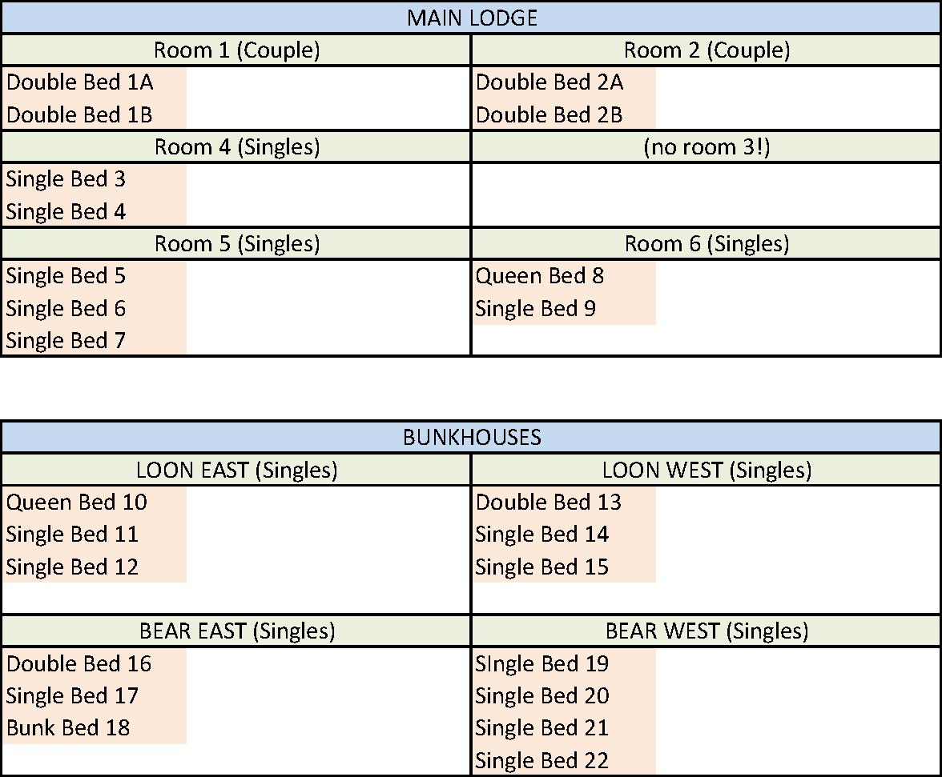
Provided will be Friday night food and snacks, two pancake breakfasts, and supplies for two sandwich style lunches. Saturday night dinner will be potluck. The closest urban center is Huntsville on Hwy 60 if you are hungry on the way in Friday night or want to have dinner before driving back home Sunday. For Sunday, “3 Guys and a Stove” or “That little place by the lights” are popular dinner spots. They need to be reserved though.

Activities:
The area offers cross country skiing, snow shoeing, and hiking. The hostel is a 20 minute walk to Ragged Falls on the Oxtongue River for snow shoeing. The Beetle Lake Trail, and nearby cross country trails, are another hiking/snowshoeing option within walking distance. We will attempt a dark walk to ragged falls Saturday night.

Many will choose to ski in Algonquin Park. The fees are $17 per vehicle per day including HST. Car pooling dramatically reduces costs!
Algonquin Park has three trail networks specifically designed and reserved for cross-country (nordic) skiing. Two trails are packed and groomed on a regular basis and one wilderness ski trail is offered, where no grooming takes place.
- Fen Lake Ski Trail
- Leaf Lake Ski Trail
- Minnesing Wilderness Ski Trail (not groomed)

Arrowhead Provincial Park and the Frost Centre Trails are both nearby and popular cross country and snow shoeing destinations. Arrowhead charges $13 per person per day including HST, and the Frost Centre charges $13 per person per day including HST.

For snowshoeing in Algonquin Park, any of the Hwy 60 corridor hiking trails can be used in winter. The 5km Booth Rock trail becomes 7 km in winter since the road is not ploughed. The 10km Centennial Trail becomes 14 km in winter.

Registration:
Please register online, or print and complete the last section of this form. Send it along with a cheque or money order for $95 (or $105 if you are not a TBN member) made payable to the “Toronto Bicycling Network”. Please do not send cash through the mail.

If you are using mail, please send the form with payment to:
paul price
7 – 6449 Glen Erin Drive
Mississauga, ON
L5N 2T2
Send us an email at the same time so we can reserve your bed choice.

When you register, you will receive a confirmation email (or regular mail) with an attachment providing directions to the hostel, an itinerary, and more suggestions on what to bring. When you register online, the email you get when you complete payment will contain a link to download the same attachment.

The hostel is about a three hour drive north of Toronto on Highways 400, 11, and 60.

Because of the facility and the options available in the area, this is an “all weather” weekend trip.

Car Pooling:
While we will not organize car pooling, we will help in the process. Contact us for more information. For car poolers, if you can not find a ride, we will refund your online payment or return or destroy your cheque.
If you can provide a ride to someone, it is greatly appreciated. It’s a good way to defray your travel costs and you get to meet a nice person to make the long drive a lot shorter.

Suggestions on what to bring for the weekend:
Potluck Dinner: - Saturday night dinner is a group effort, bring a dish you wish to share.
Bathing suit – there is a sauna cabin.
BYOB – alcohol is welcome if you are so inclined
Slippers – Shoes are removed in the foyer of the Main Lodge
Skiis and appropriate clothing

What not to bring:
Bottled Water – the hostel suggests using their “beautiful UV filtered water”
Plates, cups, and cutlery – the hostel has everything you need
Bedding, linens, comforters, and towels – these are provided by the Hostel

Cancellation Policy:
TBN weekend trips are not subsidized and cannot lose money. Last minute cancellations make it difficult to run an event. We purchase food before the weekend, and in the case of Wolf Den, have to pay for all the beds in the hostel whether used or not. Please refer to TBN’s weekend trip policy for specifics.
Our goal for these weekend outings is to provide an inexpensive getaway from the city where people can enjoy the outdoors, activities, relaxing, and the company of other nice people.

paul price, & Brenda Sweet
905-567-1035 (home – no voicemail)
wolfden@tbn.ca
use our home email: paul@pnetfit.com if you have any problems with the above

Toronto Bicycling Network
Wolf Den Weekend Getaway
February 26 to February 28, 2016

Name: __________________________________________________________
Gender: M / F (sorry, it’s not always obvious from the name)
Phone Number: __________________________________________________________
TBN Member? Yes / No
Correspondence: Email / Mail (if mail, we will need your address)
Email or Address: __________________________________________________________
__________________________________________________________
Do you need a ride (carpooling)? Yes / No
Can you help by providing transportation to someone? Yes / No
If yes, what intersection are you close to: _______________________________________
If you are offering or asking for a ride, what time were you thinking of leaving: _____________
Bed Preference (check TBN website for beds remaining): 1 ___________, 2 ____________
I would like to be in the same room with: ___________________________________________________

Food Restrictions: Vegetarian Pork Free Gluten Free Peanut Allergy
Other: ________________________________________

I agree to the terms of the TBN waiver on the next page Yes / No (no need to sign)
Comments: __________________________________________________________
__________________________________________________________
__________________________________________________________
__________________________________________________________
__________________________________________________________
__________________________________________________________

Waiver:

I HEREBY RELEASE AND FOREVER DISCHARGE the Toronto Bicycling Network Inc., their officers, directors, employees, agents and other representatives ("Released Parties"), from all claims, demands, and causes of action, whether in law or equity, in respect of death, injury, loss or damage to my person, the registrant undersigned for whom I am the parent or guardian (The Registrant) or property however arising as a result of my participation or the participation of The Registrant in any activity organized and/or sponsored by this TBN organized weekend trip. I understand that this release includes the release of all claims, demands and causes of action, which may arise by reason of any intentional act, negligence, gross negligence, error or omission on the part of the Released Parties. I declare that this release is binding upon me, my heirs, executors, administrators, and assigns, and those of The Registrant. I FURTHER UNDERTAKE TO HOLD AND SAVE HARMLESS AND AGREE TO INDEMNIFY the RELEASED PARTIES from and against any and all liability incurred by any or all of them arising as a result of, or in any way connected to, my participation or the participation of The Registrant in any activity organized and/or sponsored by the TBN. BY SIGNING THIS AGREEMENT I ACKNOWLEDGE HAVING READ, UNDERSTOOD, AND AGREED to the above RELEASE AND INDEMNITY. I WARRANT that I am at least 18 years of age, physically fit to participate in this weekend trip, and that all my equipment is mechanically fit and suitable for its intended use in such activities, and that I shall heed all traffic laws and wear a CPSC-, CSA-, SNELL-, or ANSI-approved cycling helmet.

Rev. 002, 3 June 2013

